ASSIGNMENT 11

NAME –SHAIK MOHAMMED RAIHAN ROLL NUMBER –DXC262AB12036 BATCH – DXC-262-ANALYTICS-B12-AZURE COMPANY – DXC TECHNOLOGY EMPLOYEE DOMAIN –AZURE ANALYTICS

TRAINING UNDER – MANIPAL PRO LEARN TRAINER NAME – MR. AJAY KUMAR DATE OF SUBMISSION – 17TH JUNE 2022 NO.OF QUESTIONS: 8

# Write a python program to predict car sales of a company by using below data, year : 2010 2011 2012 2013 2014 2015 2016 2017 2018 2019 2020

**Sales in millions: 169 199 262 301 345 398 501 595 610 700 720**

**display outcome using linear regression method.**

**Ans: PYTHON PROGRAM**

**#car sales of a company import matplotlib.pyplot as plt import numpy as np #importing model**

**from sklearn import linear_model**

**year = [2010, 2011, 2012, 2013, 2014, 2015, 2016, 2017, 2018, 2019, 2020]**

**sales_in_millions = [169, 199, 262, 301, 345, 398, 501, 595, 610, 700, 720]**

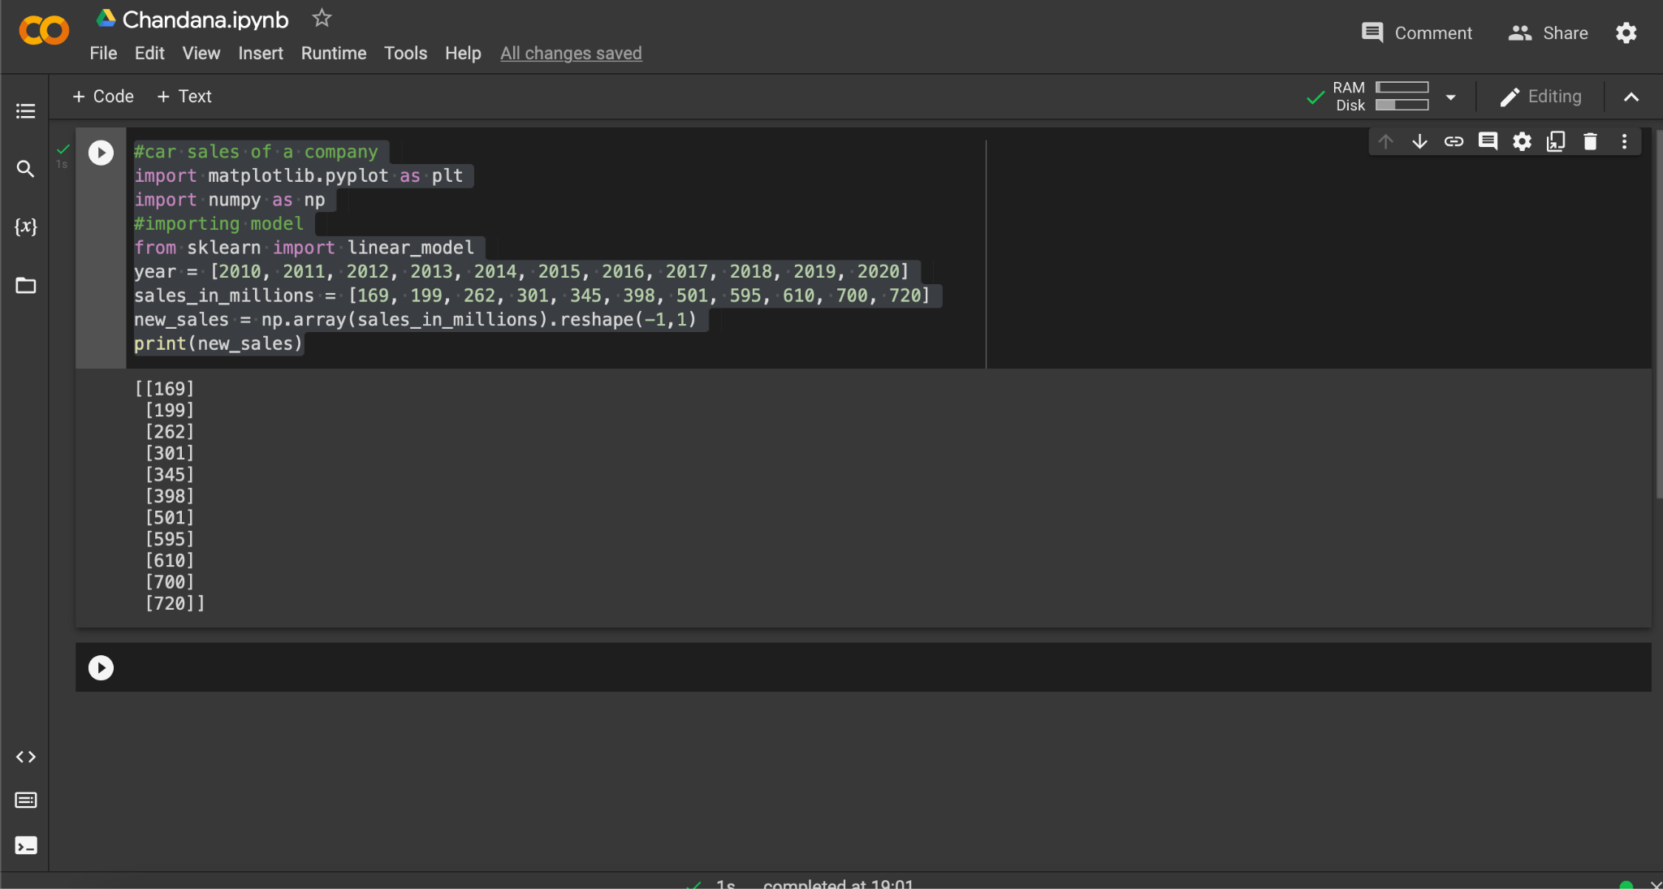**new_sales = np.array(sales_in_millions).reshape(-1,1) print(new_sales)**

**#Load model**

**r = linear_model.LinearRegression() #Fit data into the model r.fit(new_sales,year)**

**#coefficient print("coefficient: ",r.coef_) #intercept**

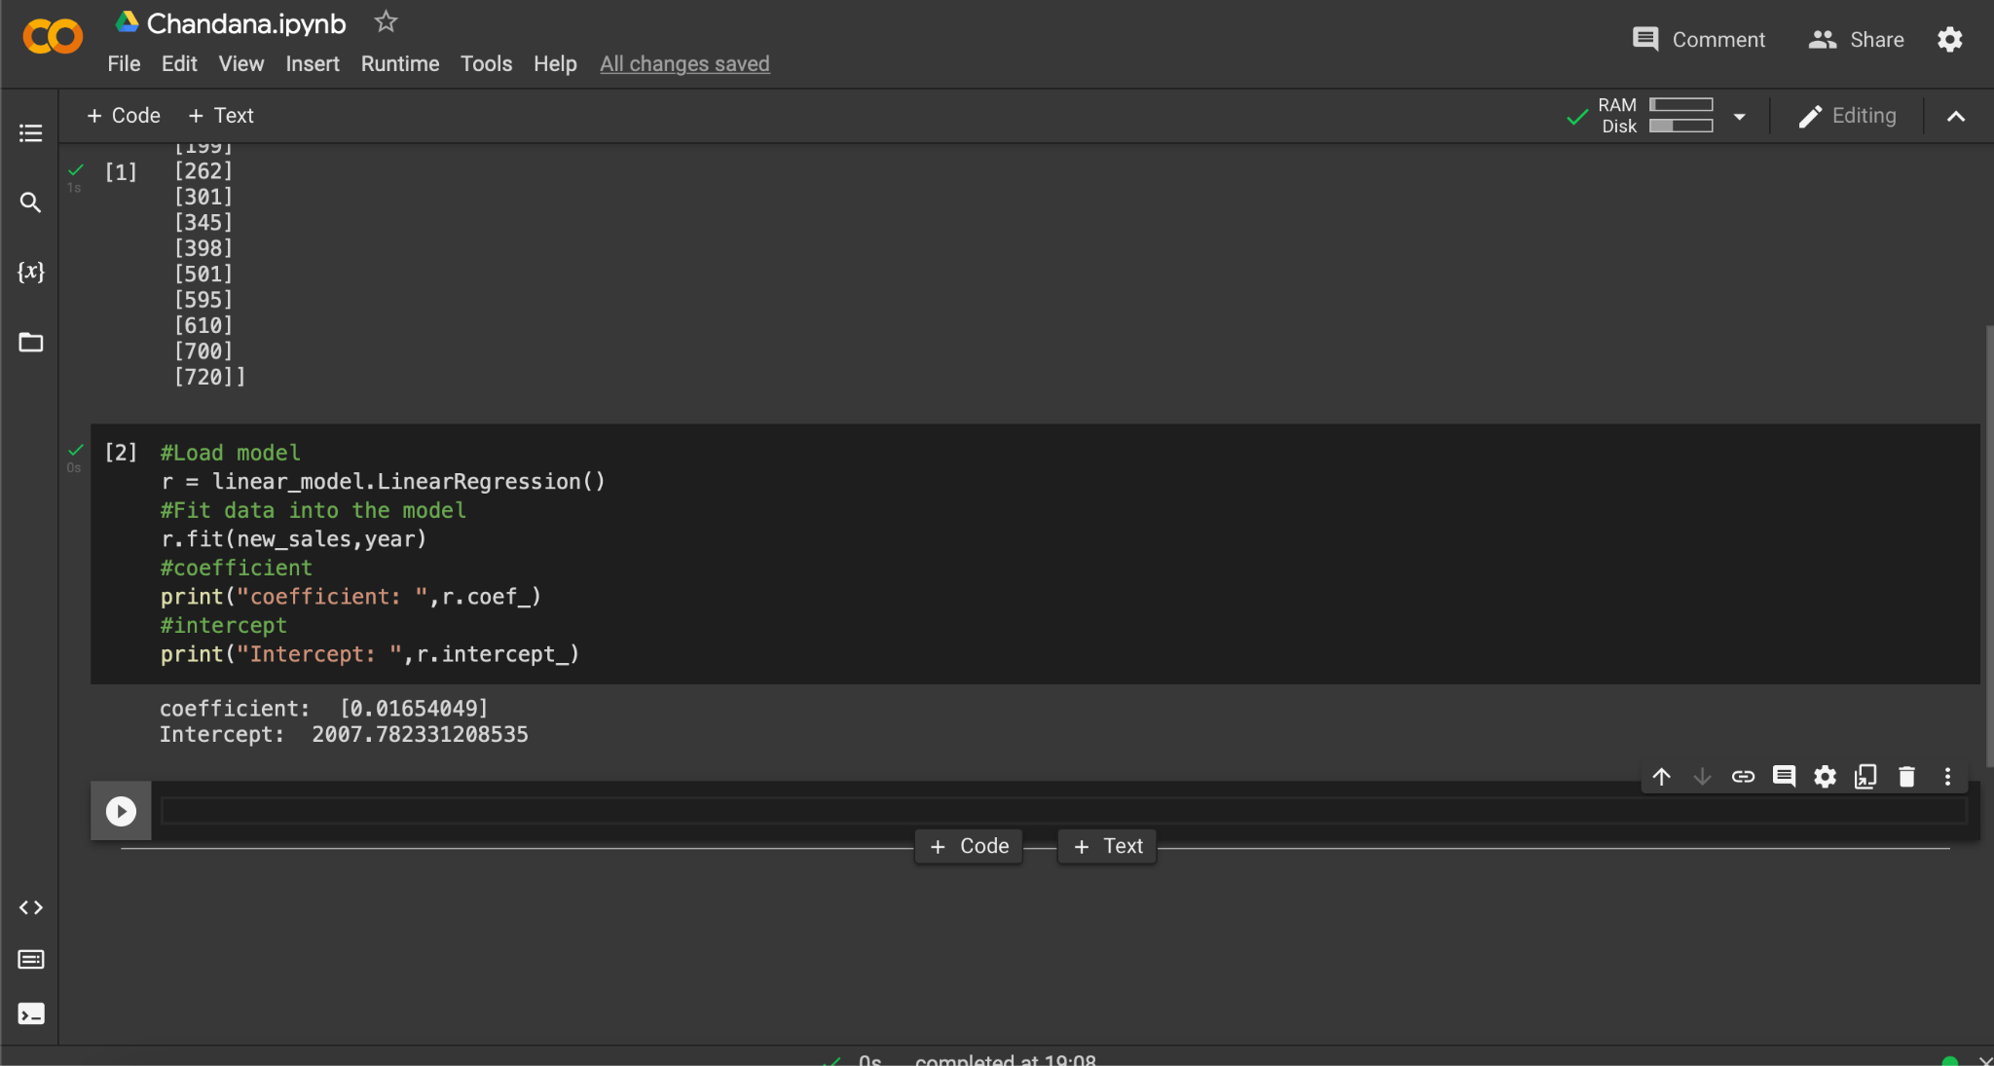**print("Intercept: ",r.intercept_)**

**def graph(formula,x_range): x=np.array(x_range) y=eval(formula) plt.plot(x,y)**

**#plotting the prediction graph('r.coef_*x+r.intercept_',range(0,2500)) plt.scatter(new_sales,year,color='purple') plt.ylabel('year')**

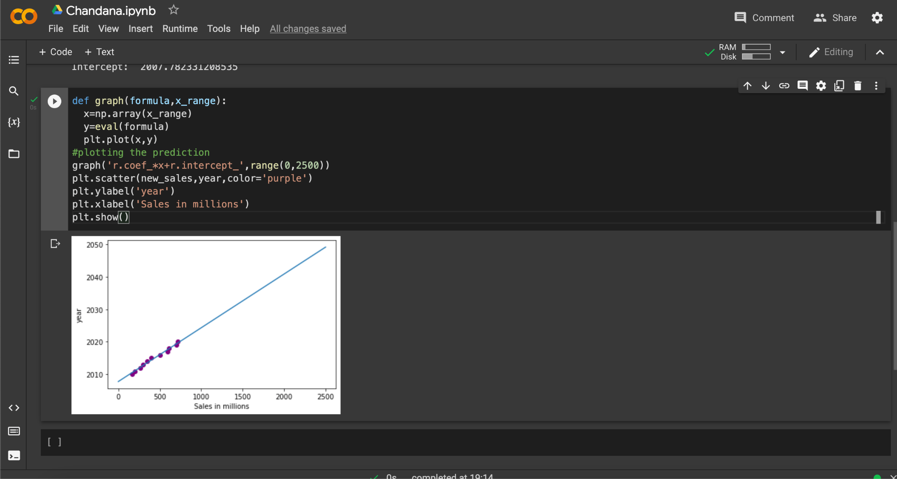**plt.xlabel('Sales in millions') plt.show()**

1. **Write a python program to generate possible tuples from any two sample Lists.**

**Ans: PYTHON PROGRAM TO GENERATE POSSIBLE TUPLES FROM ANY TWO SAMPLE LISTS.**

# #python program to generate possible tuples from any two sample Lists l1=[1,2,3,4,5,6,7]

**l2=[8,9,2,3,4,5,6]**

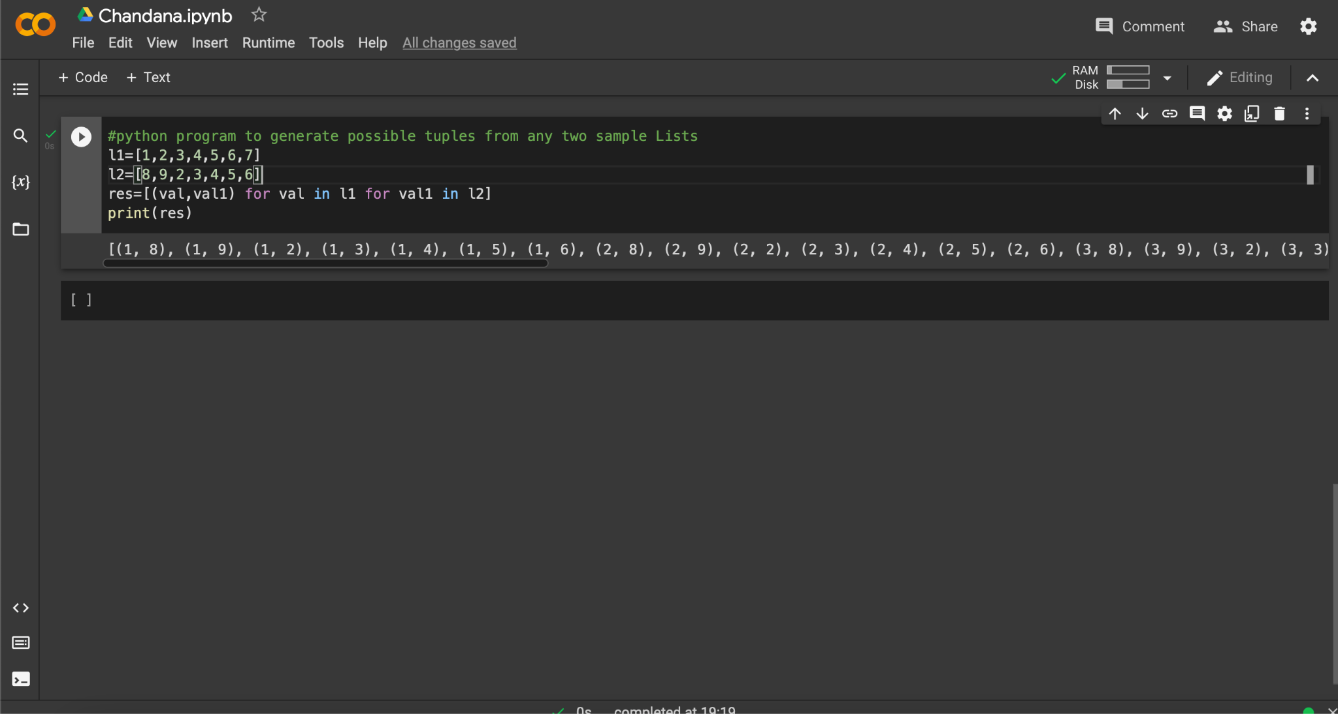**res=[(val,val1) for val in l1 for val1 in l2] print(res)**

1. **Create Azure Databricks & try to connect databricks & powerBI , explain the steps with screenshots.**

**Ans:** To create Data Bricks we have to follow the following steps.

**Step-1:** Login into the azure portal and search for the Data Bricks.

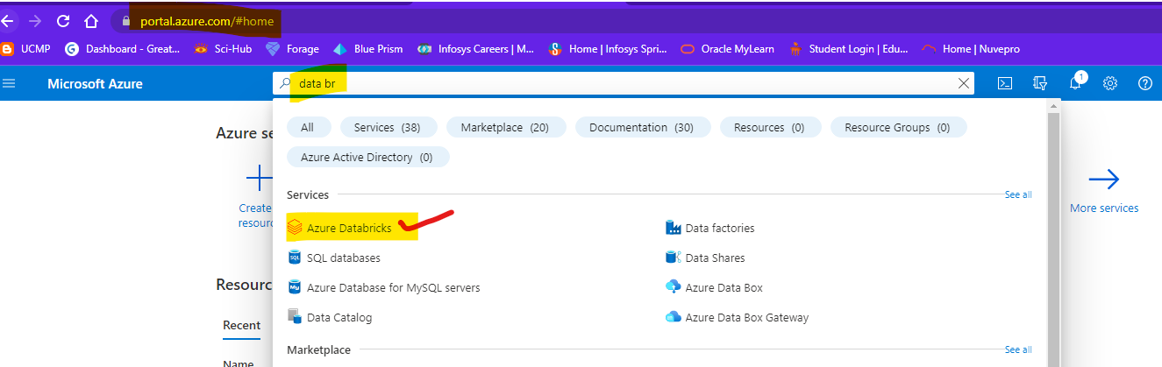

**Step-2:** Click on “Azure Data Dricks” and it will navigate you to the page. And click on “create” to create Data Bricks.

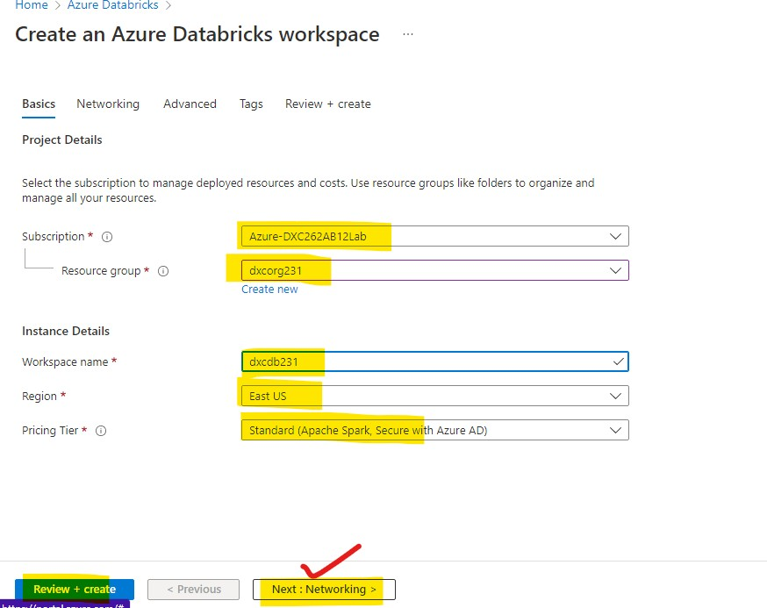

**Step-3:** After checking all these reviews and creating and waiting for deployment after deployment we will get like this.

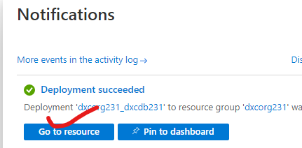

**Step-4:** After clicking the go to resource button you are navigated to the Data Bricks.

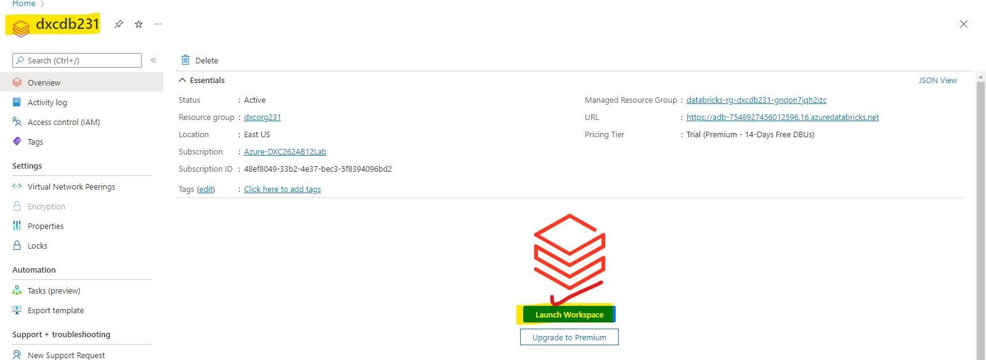

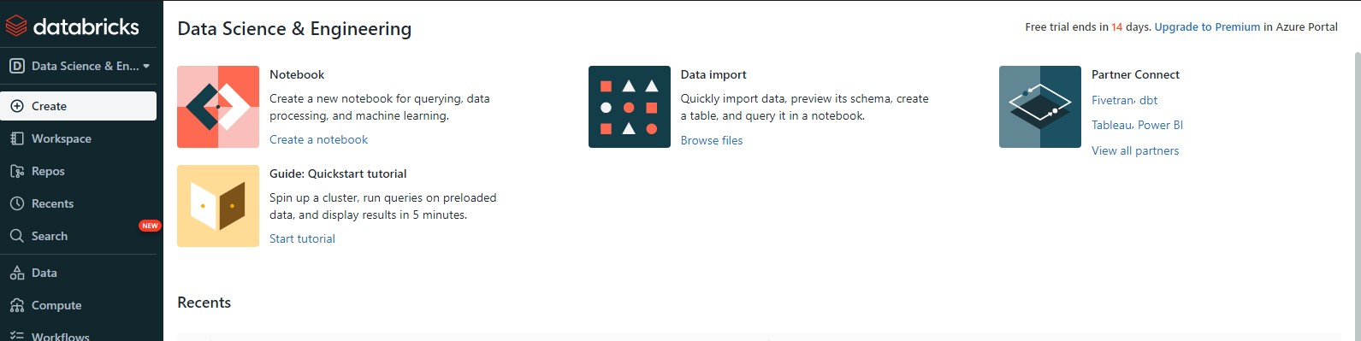

**Step-6:** After that open user settings and generate a token . After that, go to tables and click on partner connect and select the “**power BI**” and attach the cluster and download the file as shown below.

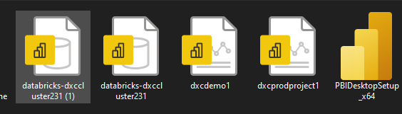

**Ans: Step-1:** Create an “**Azure Synapse Account**”.

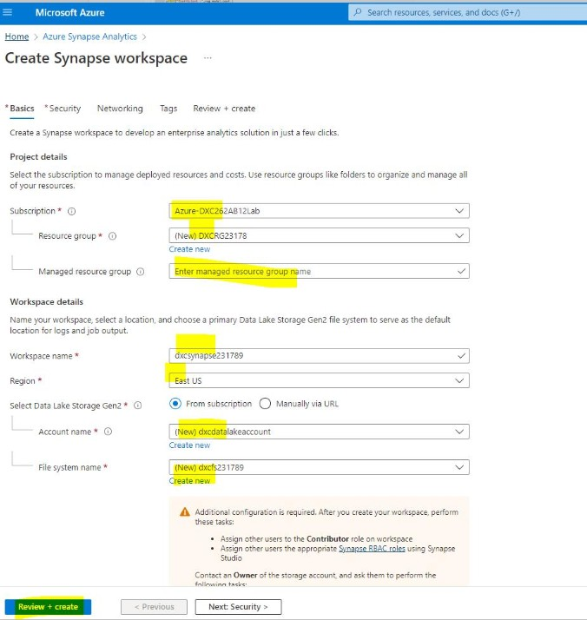

**Step-2:** Wait for the Deployment.

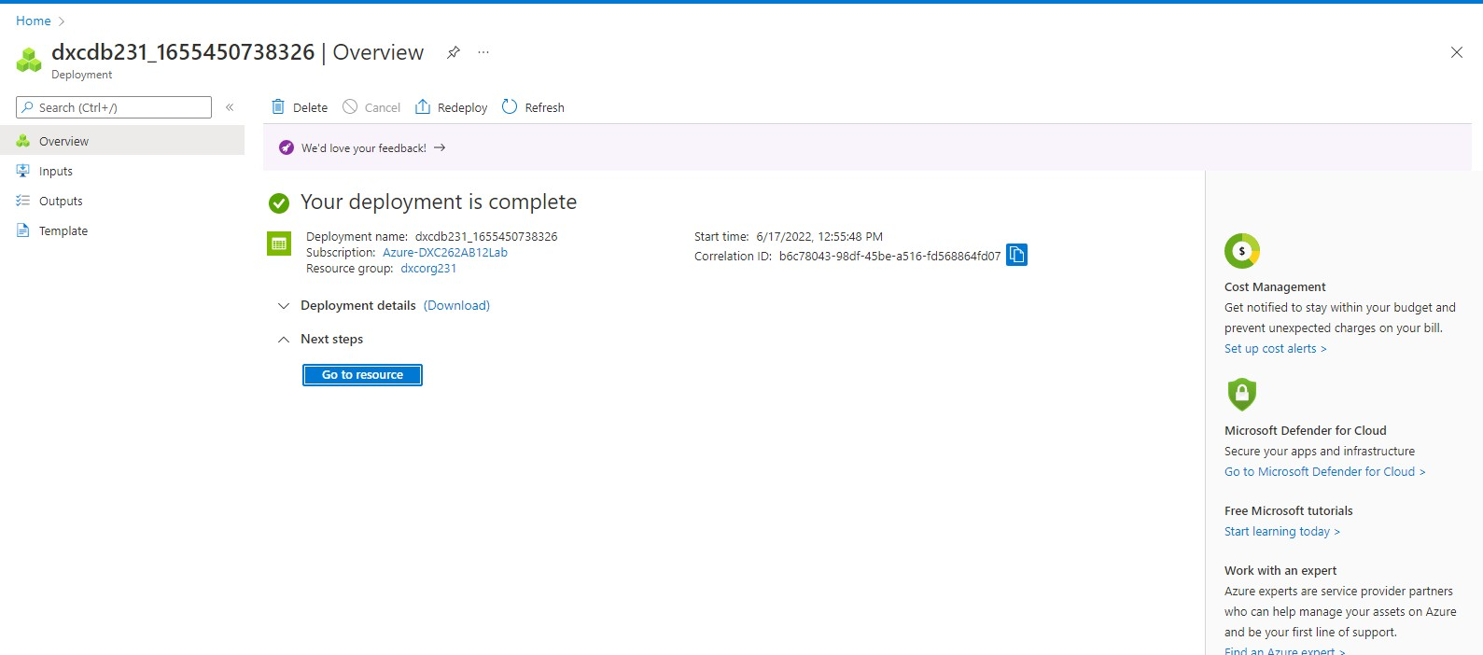

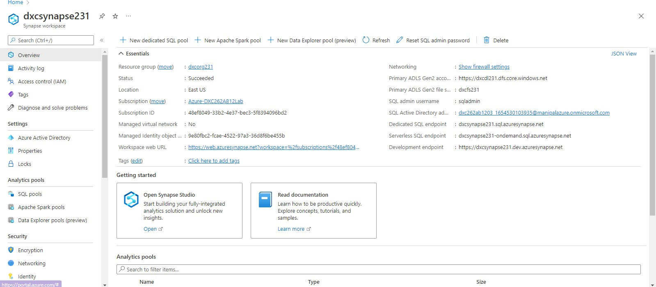

**Step-4:** This page will appear.

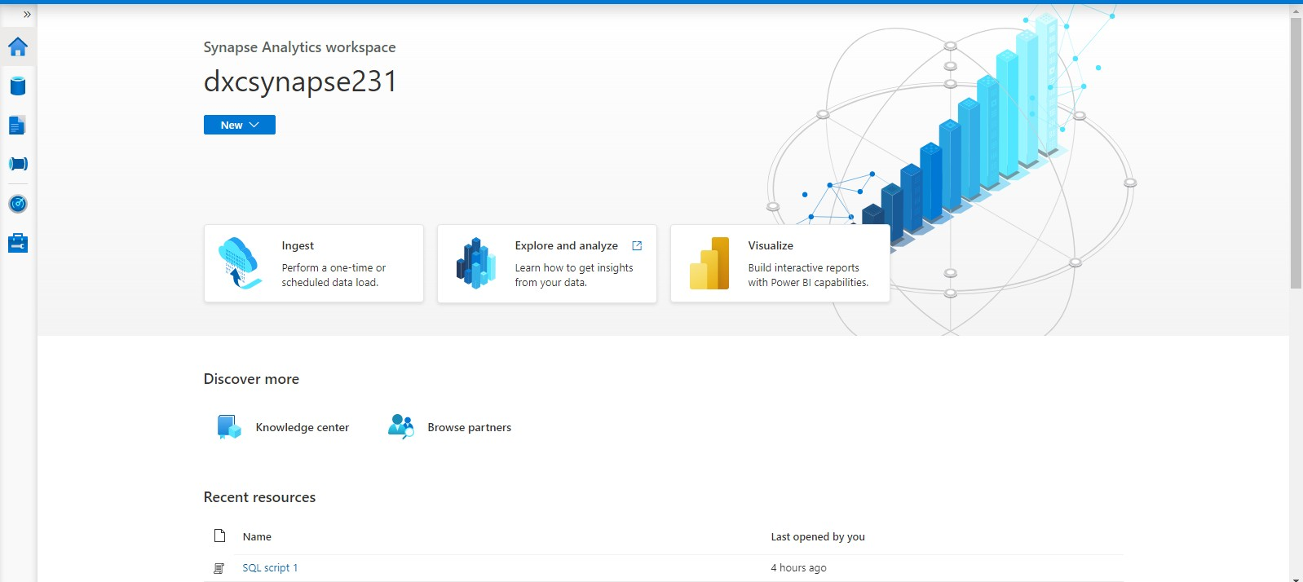

**Step-5:** Click on data after that click on connect external data as shown in the screen.

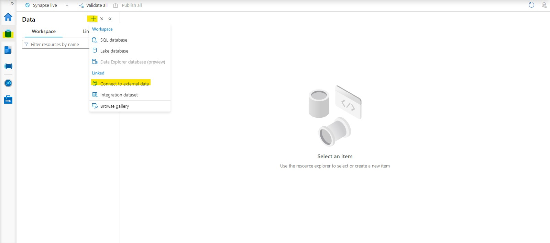

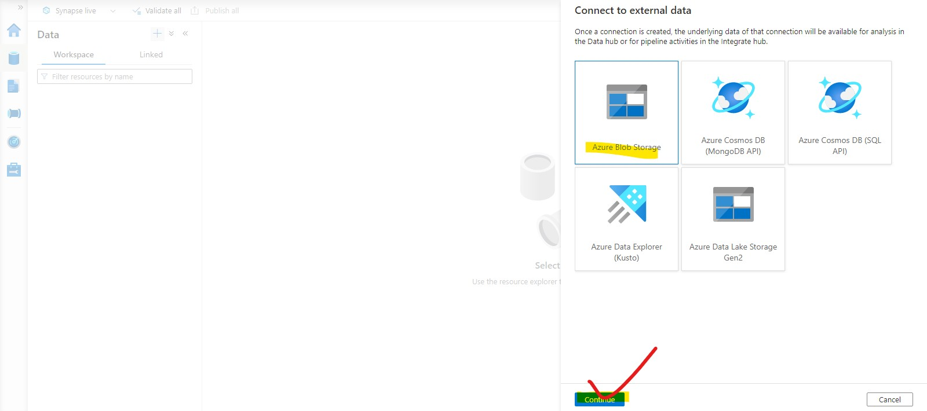

**Step-7:** New linked services page will open give the info required and check connection and later click on create.

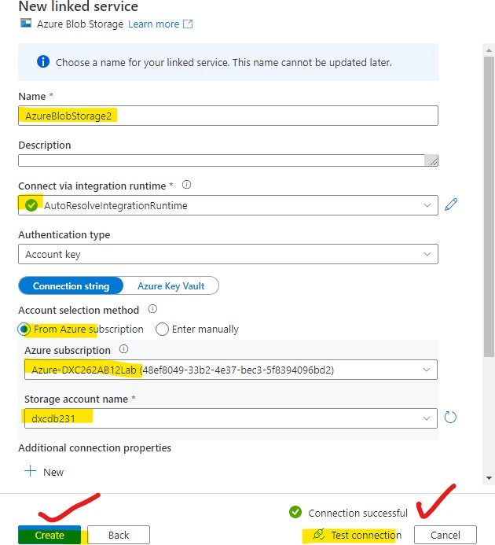

**Step-8:** After that the blob storage is connected successfully.

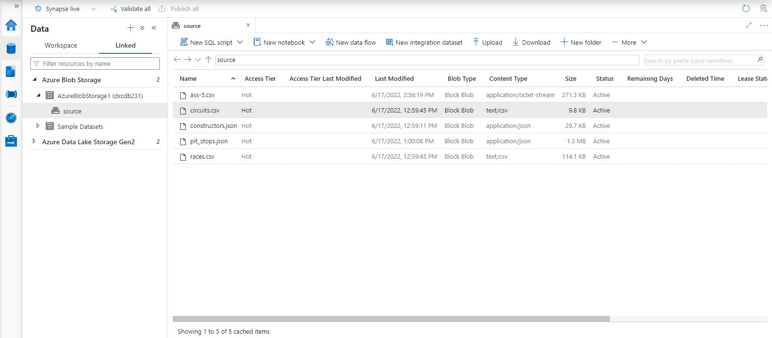

**screenshots.**

**Ans:** To create a spark pool we have to follow the steps mentioned below.

**Step-1:** Click on manage pools in Synapse.

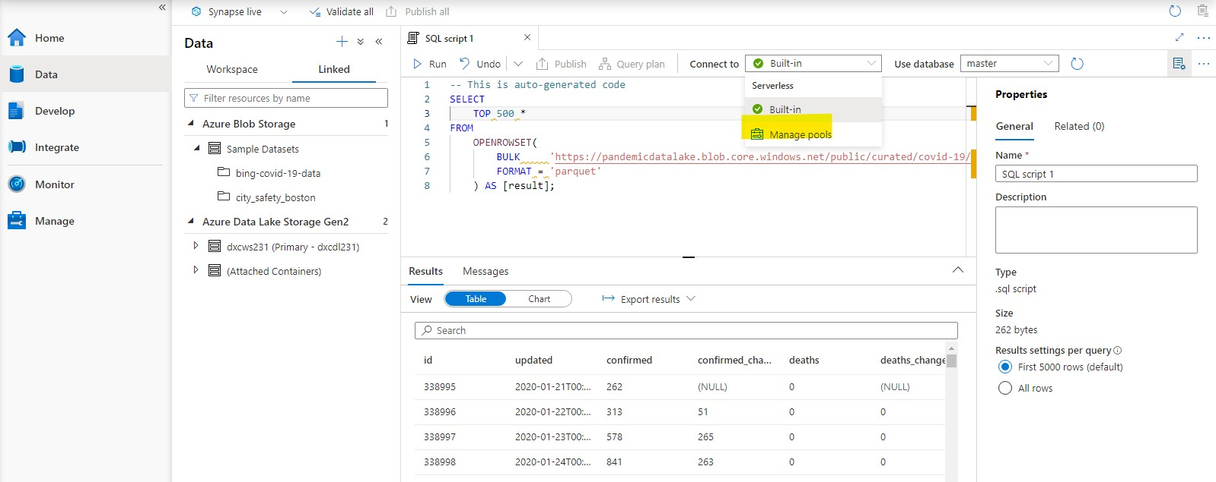

**Step-2:** After that it navigates to the mange page and selects spark pool there, refer screenshot.

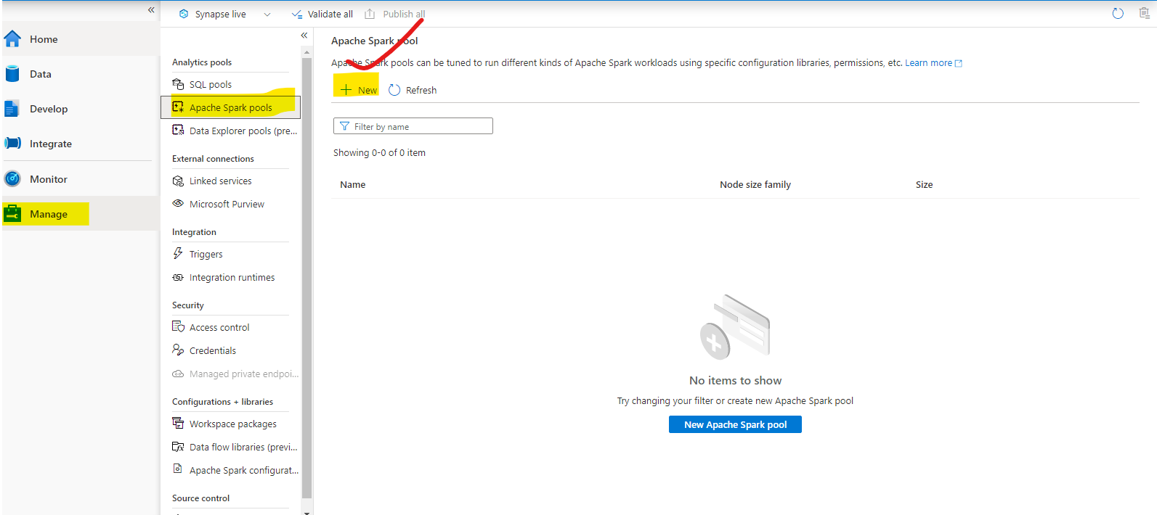

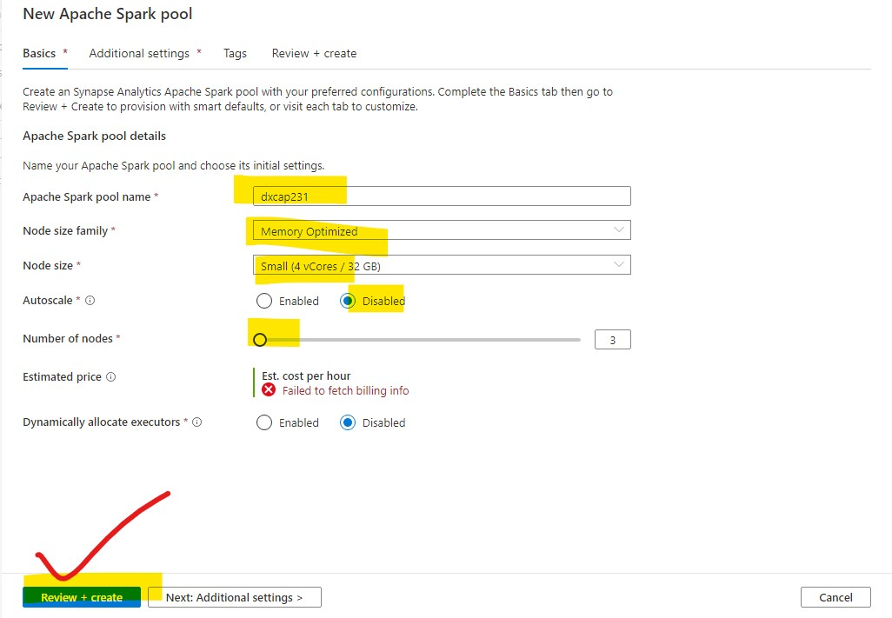

**Step-4 :** It takes a few minutes to Deploy.

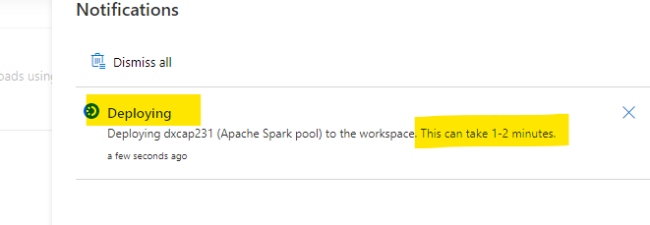

**Step-5:** And Done.

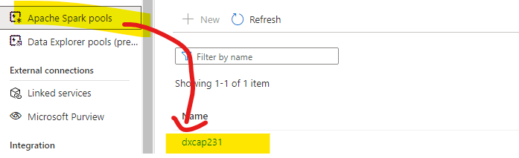

time.

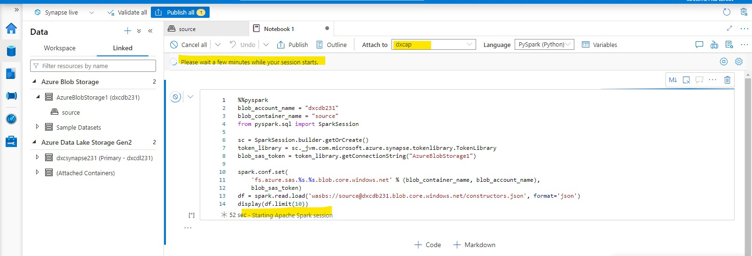

**Step-7:** The data will be queried successfully as shown in the screen.

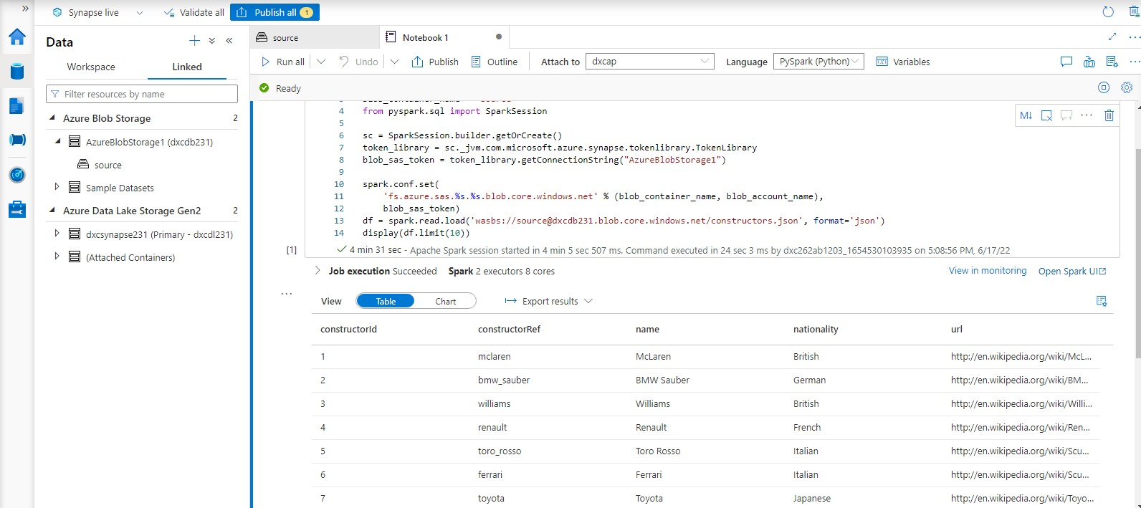

**Ans:** To create Azure cosmos DB we need to follow the below mentioned steps.

**Step-1:** Go to azure portal and search for “Azure cosmos DB”.

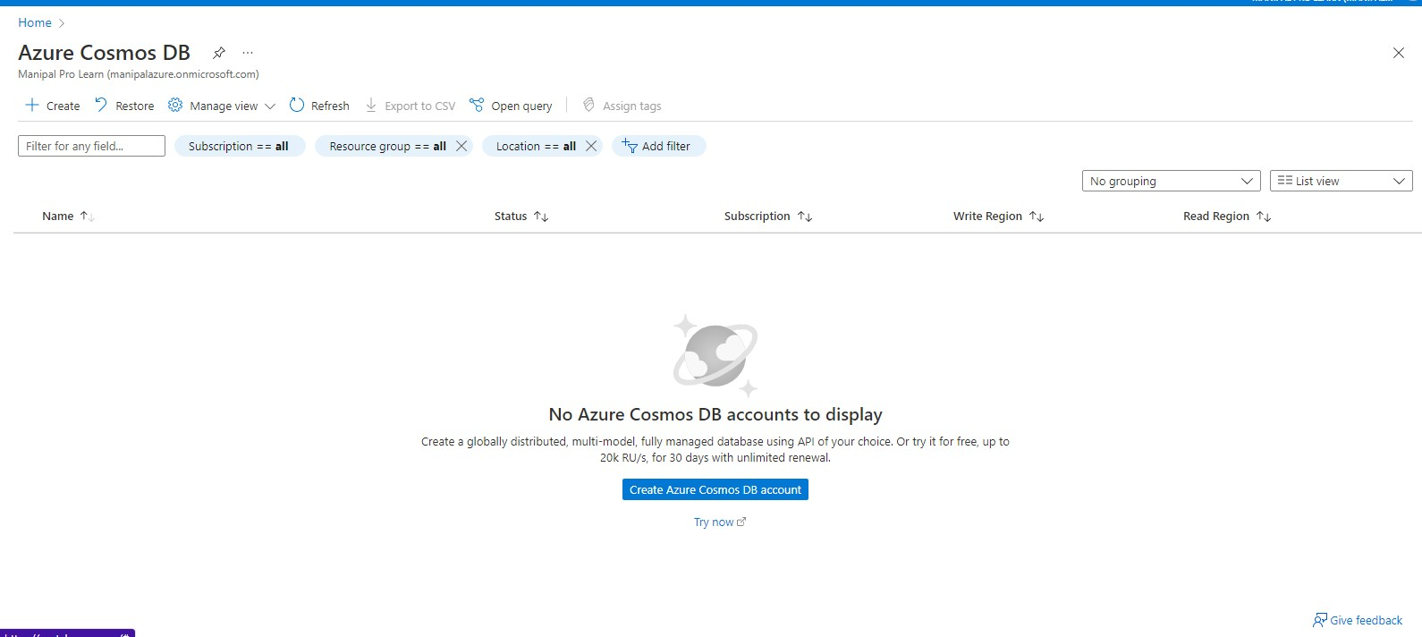

**Step-2:** We have to select the API option and we are recommended with core sql.

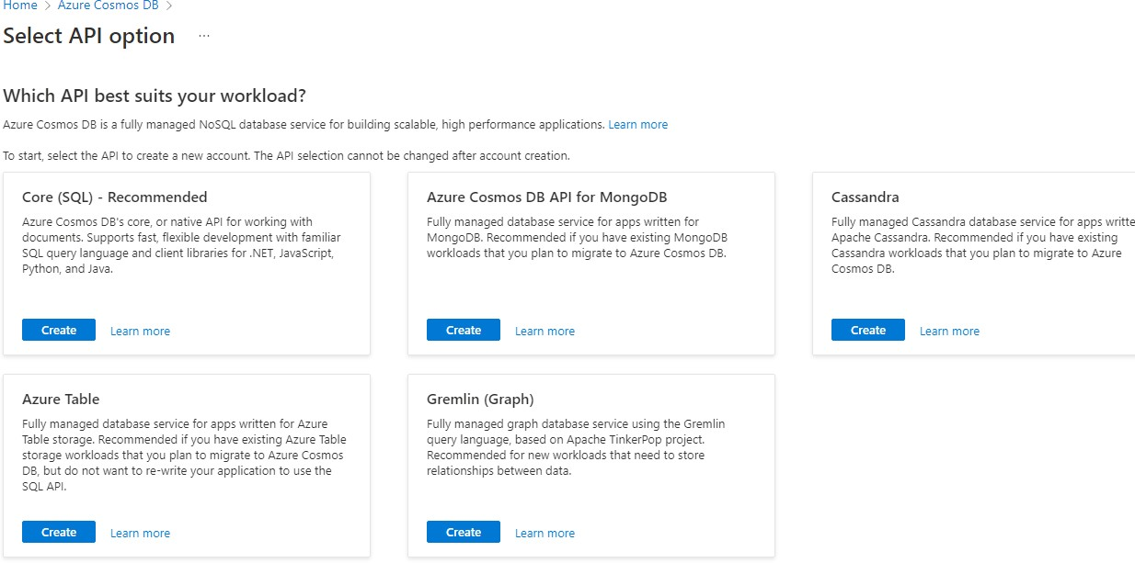

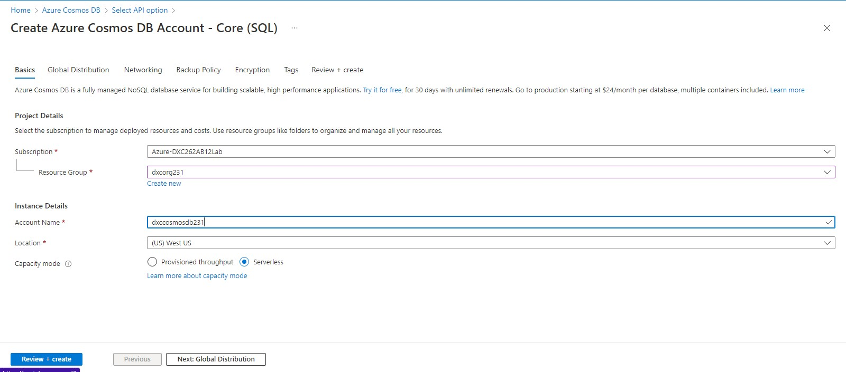

**Step-4:** After successful validation click on create.

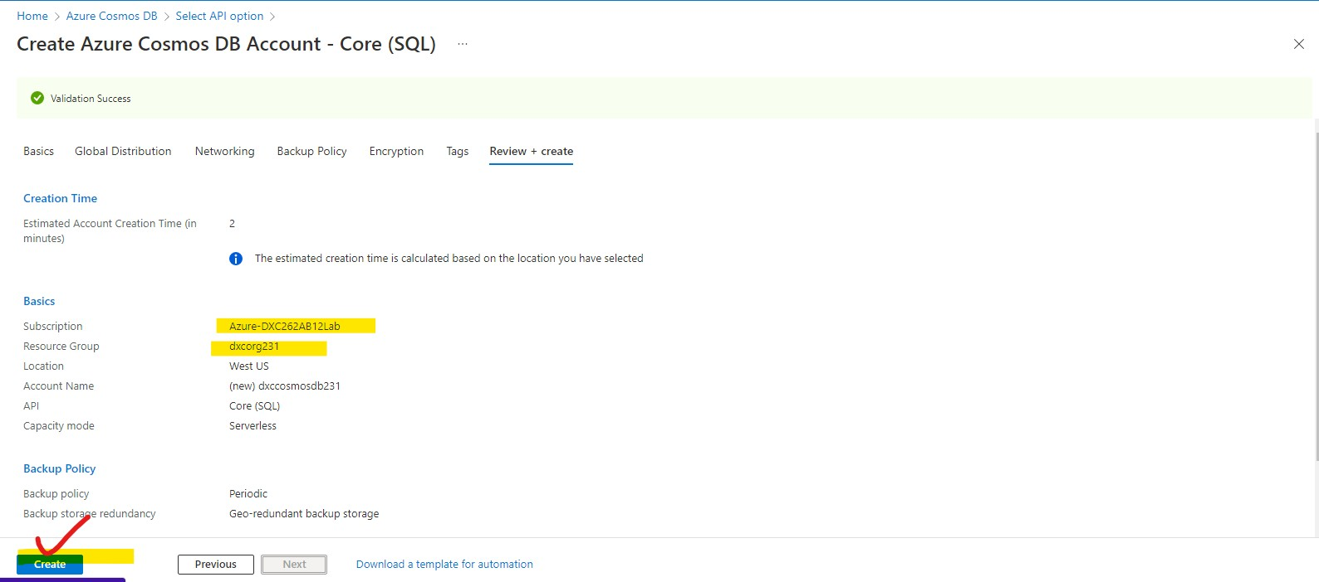

**Step-5:** Wait for the deployment to complete.

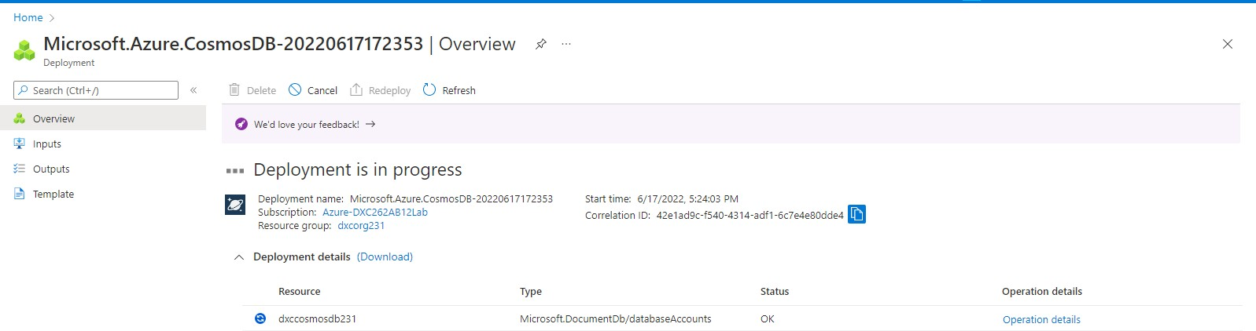

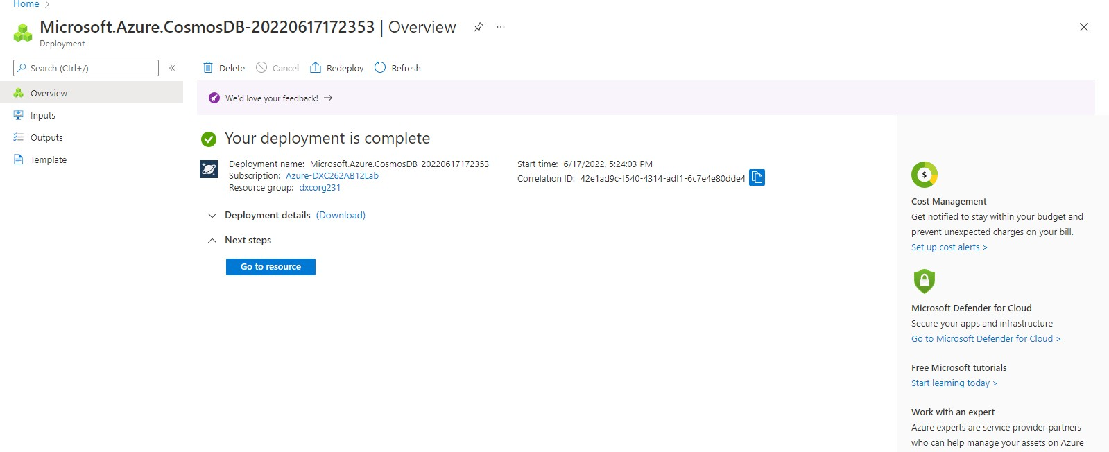

**Step-7:** After going to the cosmos DB and follow the below mentioned steps.

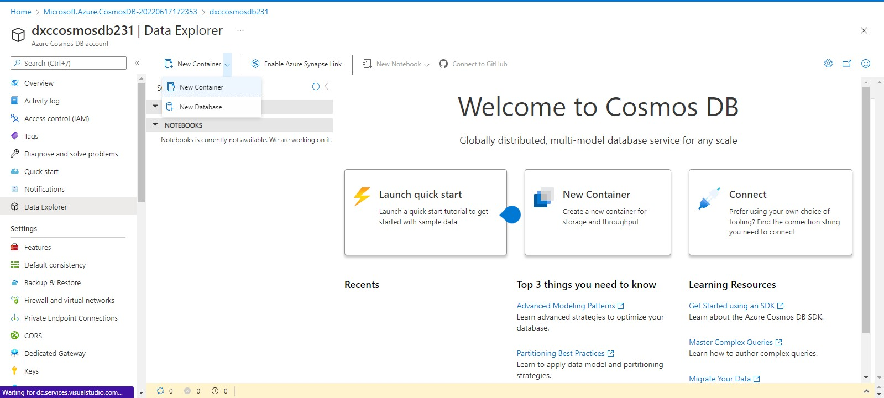

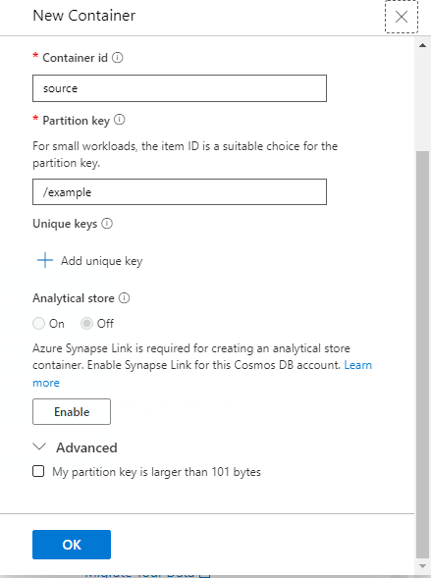

**Step-8:** Upload the data as shown below screen and After clicking on execute query then the data will be queried.

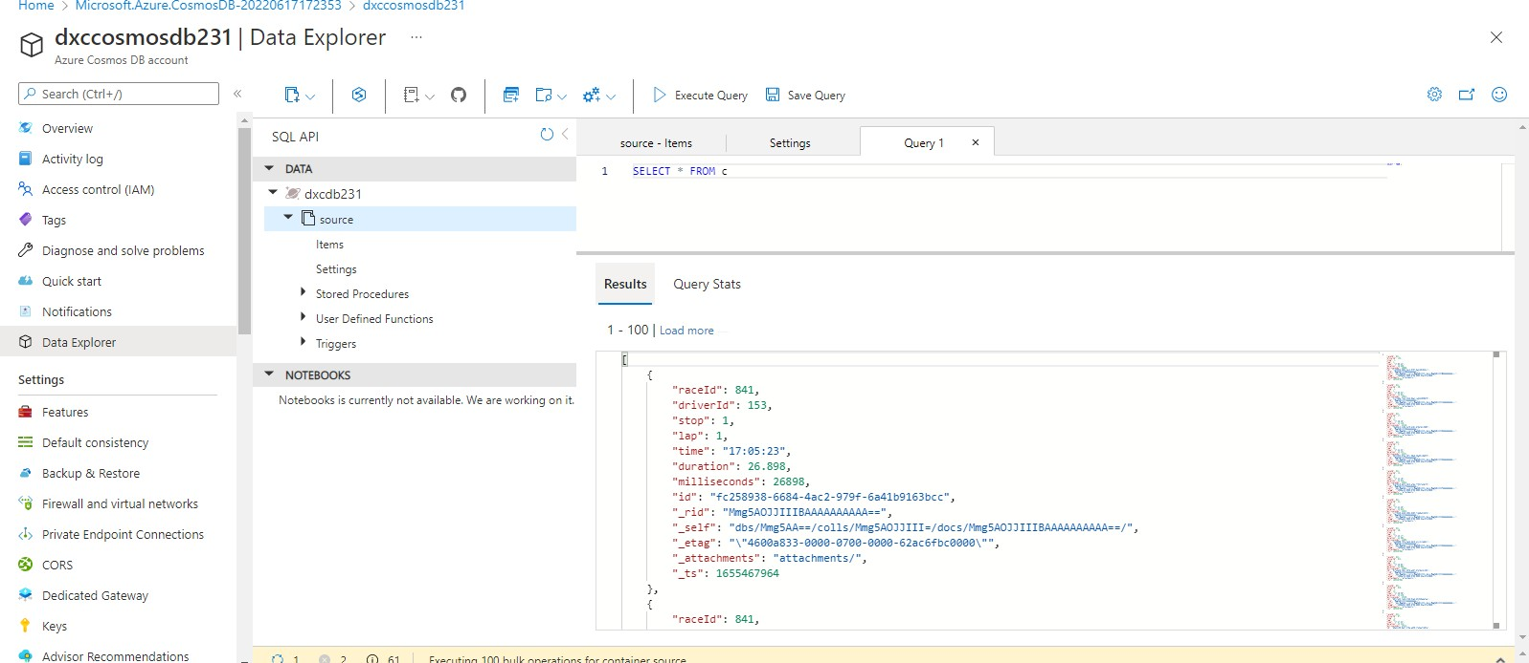

**Ans:** To connect the Cosmos DB and Azure synapse we have to follow the below mentioned steps.

**Step-1:** Open azure synapse and click on data and click on + icon and select connect external data.

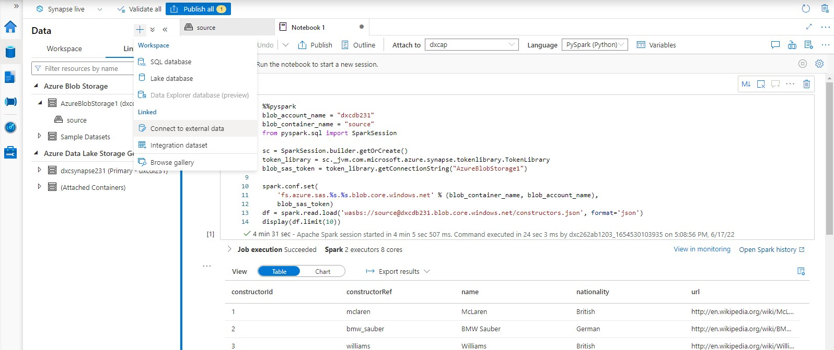

**Step-2:** Then select the cosmos DB SQL API.

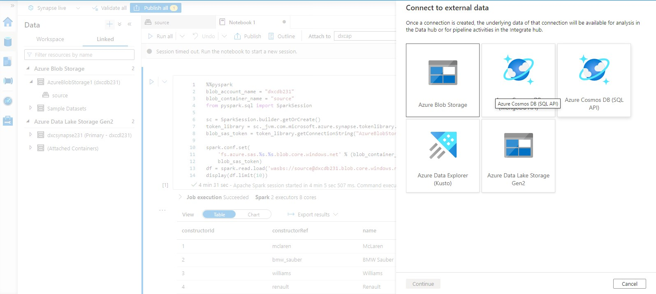

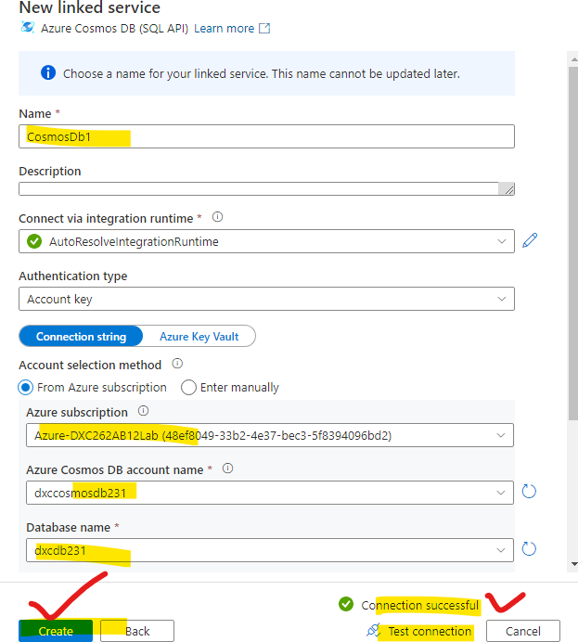

**Step-4:** After that cosmos DB is successfully connected with synapse.

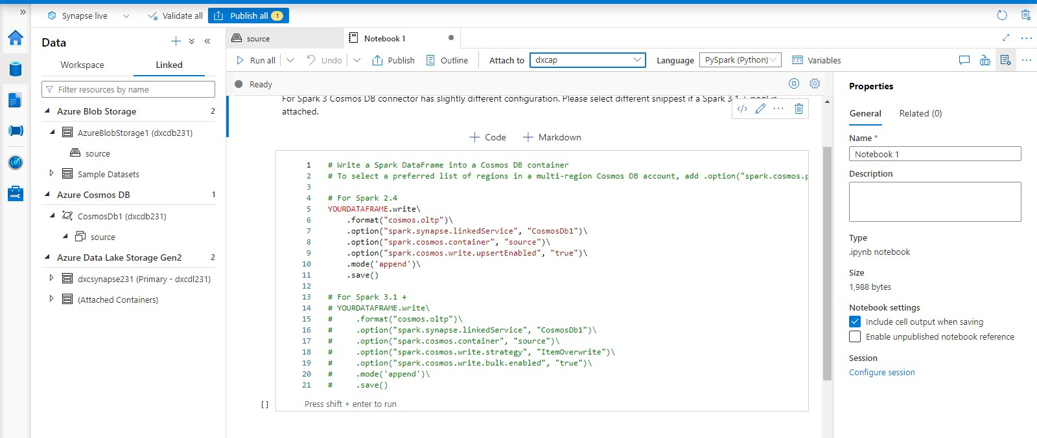

**factory & explain the steps with screenshots.**

**Ans:** Azure data factory can be created by using the following steps

**Step-1**: Login to the azure portal and search for azure data factory as shown in figure.

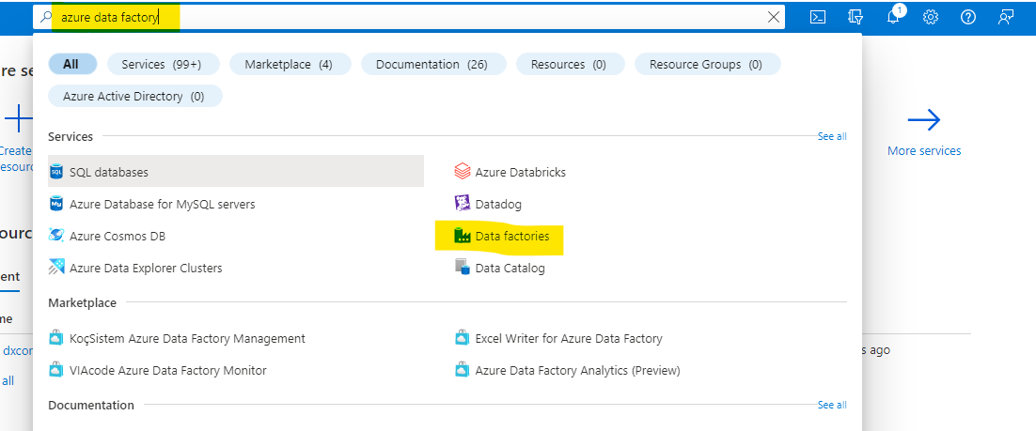

**Step-2:** After navigating to the azure data factory page click on create and select the resource group, name, region, version after that click on next follow the figure.

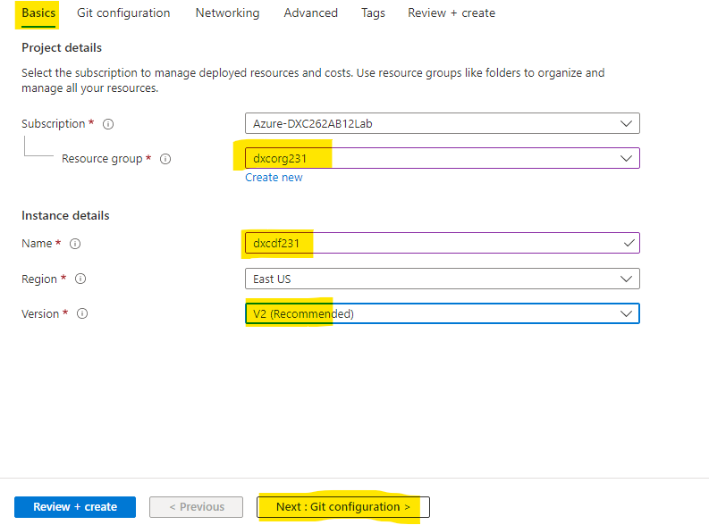

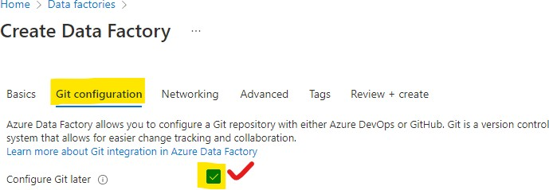

**Step-4:** Go through the next steps followed by successful completion of validation click on create as shown in figure.

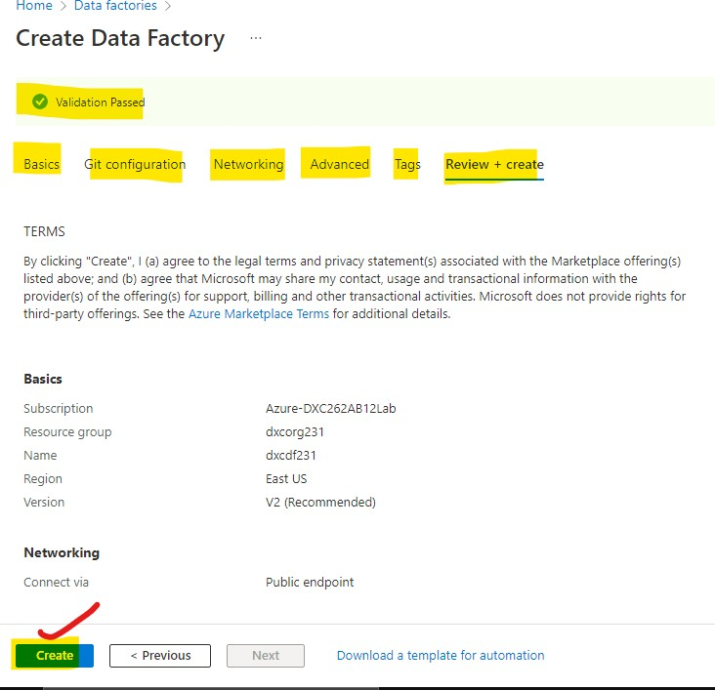

the following as shown in figure.

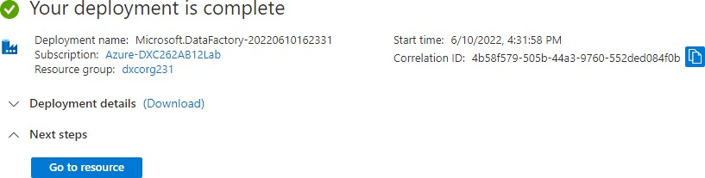

**Step-6**: Click on go to resources after that click on open as shown in the figure.

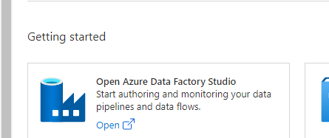

**Step-7:** After clicking over it will open the azure data factory in a new window as mentioned in figure and we can use this creation of pipelines.

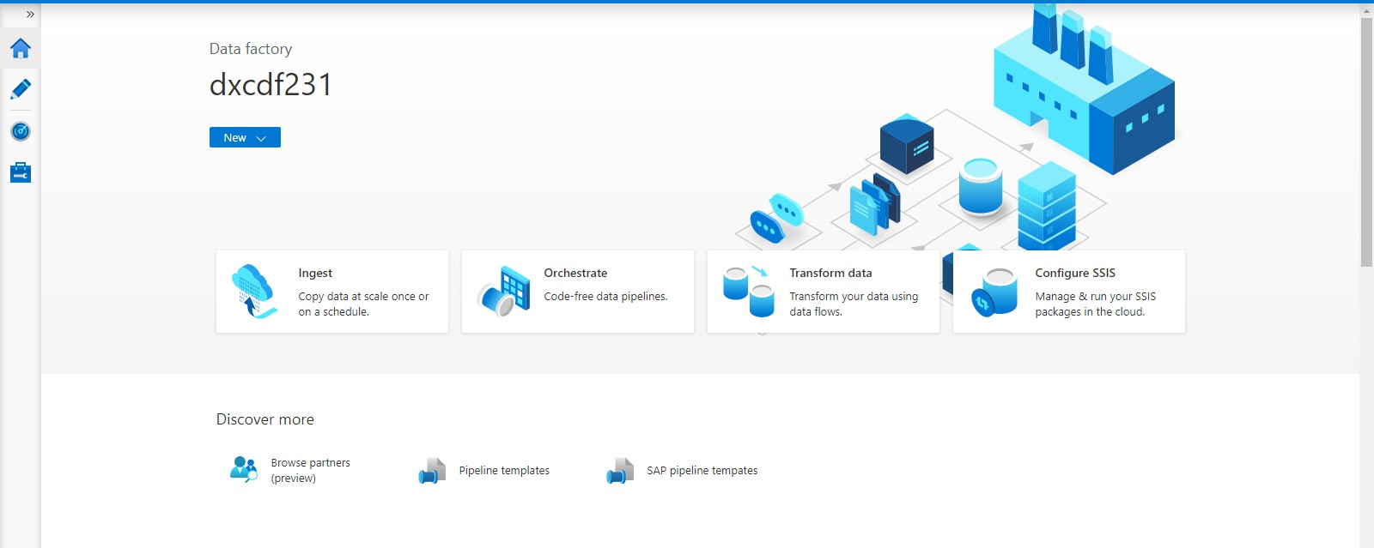

**Step-8 :** We are moving the data from the source to the destination using the copy data tool and creating a pipeline.

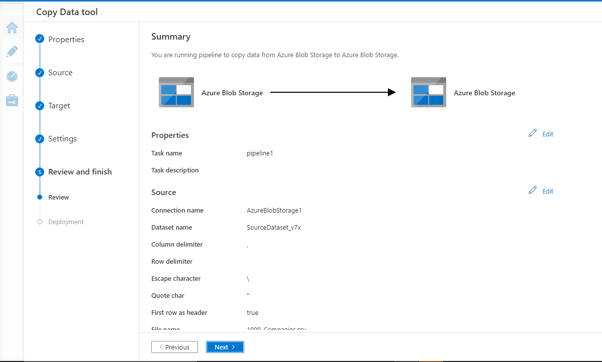

**Step-9:** The validation and deployment is done and the pipeline is created successfully.

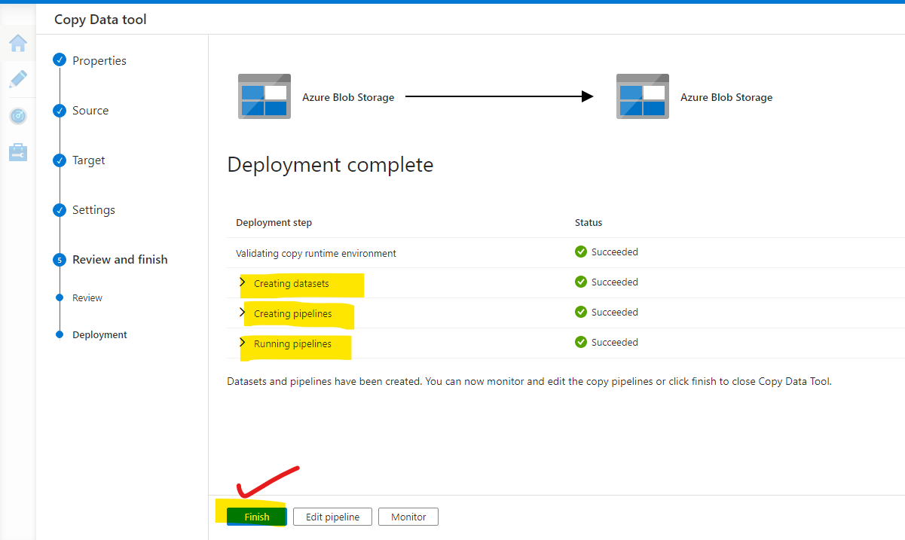

**Step-10:** The data is successfully copied from source to destination.

